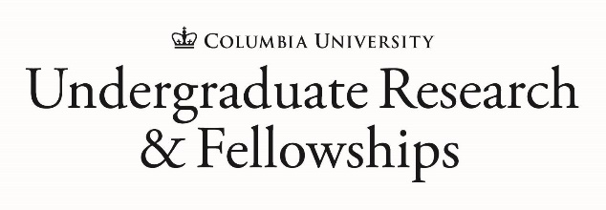 | Advising and Support for Undergraduates and Alumni/ae of Columbia College, Columbia Engineering, and General Studies
Research and fellowships offer short-term opportunities to compliment your classroom learning with added experience, knowledge, and understanding within your field of interest, while further cultivating your professional relationships with faculty or experts in your field.

Students can apply for research opportunities or fellowships at any point during their undergraduate tenure, so it is never too early to explore your options!

VISIT URF ON CAMPUS  202 HAMILTON HALL | Daily Walk-In Advising  Monday through Friday  12:00 PM – 1:00 PM
VISIT URF ONLINE  URF.COLUMBIA.EDU | Weekly Events  - Writing Workshops  - Information Sessions  - Foundation Meet & Greets  - Summer Webinars
CHAT WITH URF ABOUT…  - Summer Research  - Scholar Programs  - Postgraduate Degree Fellowships  - Public Service Projects  - Funding for Global Opportunities  - Connecting with Faculty  - Creating a strong fellowship application  - Exploring/Finding Opportunities of Interest | Contact URF  Ariella Lang  Associate Dean of Academic Affairs, Director, URF  al223@columbia.edu  Jodi Zaffino  Assistant Dean of Academic Affairs, Fellowship Programs  jaz2124@columbia.edu  Jessica Cubas  Assistant Director of Academic Affairs, URF  jcc2239@columbia.edu

